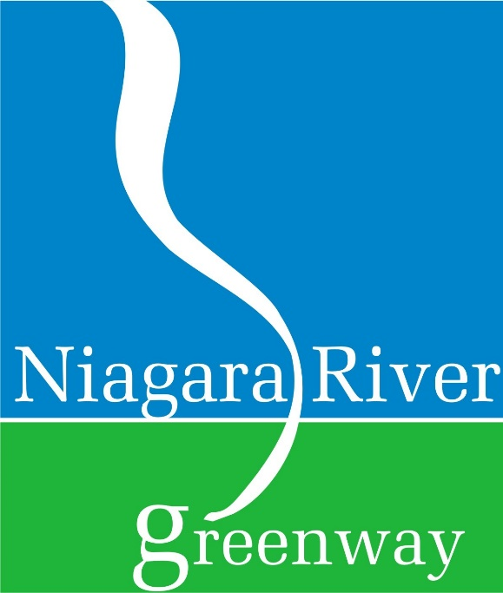

Niagara River Greenway Commission
Greenway Related Projects and Programs

Instructions
PROJECT CONSULTATION and PROJECT REVIEW

Effective October 2021

Table of Contents
- General Information on Consultation and Review Procedures ……………………. Pages 3 - 4
  - Introduction
  - Review Process
  - Niagara River Greenway Principles, Goals and Criteria
- General Instructions …………………………………………………………………………………….. Pages 5 - 6
  - Instructions for Project Review Form
- Frequently Asked Questions ………………………………………………………………………… Page 7
- Consultation and Project Review Form ………………………………………………………… Pages 8 - 10

Niagara River Greenway Vision
The Niagara River Greenway aspires to be a world-class corridor of places, parks and landscapes that celebrates and interprets our unique natural, cultural, recreational, scenic and heritage resources and provides access to and connections between these important resources while giving rise to economic opportunities for the region.

Introduction
Approval of the Niagara River Greenway Plan on May 17, 2007 marked the beginning of a new era for the Niagara River and surrounding communities. The plan defines the vision that will guide the future of this internationally renowned water resource and the principles, goals and criteria that will serve to define this vision. The Niagara River Greenway Commission is responsible for the implementation of this plan and will work toward its achievement by carrying out its duties and responsibilities as defined in Chapter 460 of the Laws of New York 2004. The guiding blueprint is the Niagara River Greenway Plan which developed as a grassroots effort in cooperation with state agencies, municipal governments, stakeholder groups and the general public. The Niagara River Greenway Plan can be viewed at www.niagararivergreenway.com

Proposals brought before the Niagara River Greenway Commission include projects for funding under the various settlement agreements through the four standing committees that were established during the relicensing of the New York Power Authority Project. In addition, other projects not seeking Relicensing Greenway funds may be brought before the Commission when the sponsor is seeking review and endorsement in conjunction with their application for various grants or approvals other than Greenway funds.

Review Process
The Niagara River Greenway Commission is responsible for stewardship of the Niagara River Greenway Plan that will define the future of the Niagara River corridor. In this regard, the Commission will review projects in terms of its operative principles, goals and criteria. Project proponents are expected to provide sufficient documentation so that members of the Commission will be able to determine if a specific project is consistent with the Niagara River Greenway Plan.

It is not the intent of the Commission to duplicate the technical review procedures that may be employed by other government agencies with regulatory or advisory authority over projects within the Niagara River Greenway. However, the Commission reserves the right to assess any project element and specification that will have an impact on the Niagara River Greenway vision.

Niagara River Greenway Principles, Goals and Criteria
The Niagara River Greenway vision, mission with its corresponding principles, goals and criteria are the standard upon which all projects brought before the Niagara River Greenway Commission are judged. The principles, goals and criteria along with the corresponding page numbers from the approved Niagara River Greenway Plan is as follows:

Principles (pages 19 – 22 of the Niagara River Greenway Plan)
Excellence Restoration
Sustainability Authenticity
Accessibility Celebration
Ecological Integrity Partnerships
Public Well-Being Community Based
Connectivity

Goals (pages 23 – 25 of the Niagara River Greenway Plan)
Improve Access Promote Long Term Sustainability
Make Connections Extend the Legacy of Fredrick Law Olmsted
Protect and Restore Environmental Systems Celebrate History and Heritage
Spark Revitalization and Renewal

Criteria (pages 27 – 35 of the Niagara River Greenway Plan)
Consistency with Greenway Principles Economic Viability
Priority Status Availability of Local Sponsor or Partner
Focus Area Ability to Match or Leverage Funds
Environmental Soundness Consideration of Other Planning Efforts
Implementable Clear Benefits

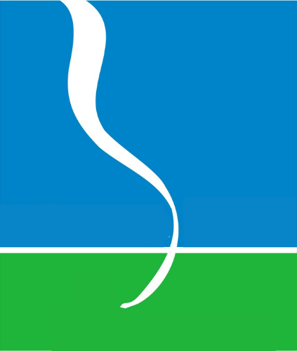
Project proposals are first submitted to the Niagara River Greenway Commission, who reviews projects for consistency with the Niagara River Greenway Plan. If found consistent, the project proposer must then apply to the appropriate Standing Committee for funding approval.
General Instructions

PROJECT REVIEW CONTENT AND FORMAT: Project information shall include all necessary information and project documentation and shall follow the order set forth above for Principles, Goals and Criteria that encompass the Niagara River Greenway Vision. Request for consultation or review will not be considered until all necessary materials have been provided.

PROJECT SPONSORS WHO ARE NOT-FOR-PROFIT CORPORATIONS: These sponsors must provide proof of their tax exempt status pursuant to the United States Internal Revenue Code.

PROJECT NAME: The project name shall be clear and concise.

PROJECT LOCATION: Provide the specific address for the proposed project. If the project is a State Landmark site or National Landmark site, use the full, official name of the property as it is listed in the appropriate State or National Register. The unofficial or popular name may be shown in parentheses after the official name. List the local historic designation, if applicable.

MINOR CIVIL DIVISION: A minor civil division is the incorporated boundary of a village, city or town in which a project is taking place. Some projects may involve more than one political boundary and if so, information shall be provided for each one.

OWNERSHIP INFORMATION: If the applicant is not the owner of the property on which the project will be located a letter or resolutions of support must be provided from the responsible property owner.

AUTHORIZED OFFICIAL: This is the designated person who will receive official notifications from the Niagara River Greenway Commission about the project.

POINT OF CONTACT: The person who will act on behalf of the project sponsor, provide additional project information and participate in the consultation process. In some instances the Point of Contact may also be the Authorized Official. If that is the case a notation should be made on the project review form.

BUDGET SUMMARY: Provide all of the information that is required on the project review form and be sure to include the required operations and maintenance plan.

PROJECT NARRATIVE: A succinct project narrative shall be prepared following the order shown in the project review form. It shall be limited to a brief paragraph describing the project and its purpose, how it will be accomplished and why it is important.

PROJECT SCHEDULE: The anticipated project schedule must be defined. Include the project planning steps, project start date, duration of construction and completion date. In addition, a list of the required regulatory permits needed for the project must be provided.

MAPS AND PHOTOGRAPHS: Submit an original, 1:24,000 scale USGS or DOT planimetric map with the proposed project site identified. To obtain maps, project sponsors may visit https://gis.ny.gov/.
Photographic prints showing the planned project area and existing site conditions shall be provided. If appropriate, include aerial photographs.

REQUIRED ATTACHMENTS: The project review form shall include conceptual plans and drawings that depict the existing site conditions and the same site with the proposed project. Highlighted sections of local planning documents and/or a copy of a resolution adopting or reaffirming the local plan within the last five years shall be included with the application. If the proposed project is not specifically identified in a formally adopted local land use plan an approval or endorsement must accompany the profile. The final attachment will be a brief description of the applicability of the State Environmental Review Act to the proposed project.

PUBLIC PRESENTATION: Sponsors may be asked to present their project profile in a public forum at a meeting of the Niagara River Greenway Commission. Comments received on specific project proposals from the public will be fully considered during the deliberations of the Niagara River Greenway Commission.

DOCUMENT SUBMISSION: One hard copy of completed document shall be submitted to Niagara River Greenway Commission, PO Box 1132, Niagara Falls NY 14303. In addition, one PDF file (no larger than 7 MB) of the completed document shall be emailed to lisa.vitello@parks.ny.gov. Upon receipt the Executive Director shall review the documents to determine that they are complete, and if necessary, the sponsor will be promptly informed of items missing in order to complete the submission.

In addition, it is the applicant’s responsibility to submit the proposal to the relevant standing committee following consistency review from the Commission. Each associated Standing Committee has a separate proposal application. Review Greenway Standing Committee websites for additional information.

Niagara Host Community: http://www.niagarapowercoalition.com/hcsc/index.php

State Parks: same application as Greenway Commission - http://www.niagararivergreenway.com

Buffalo and Erie County Greenway Standing Committee: http://niagara.nypa.gov/RelicensingGreenwayFunds/BuffaloErieGreenway/BEdefault.htm

Greenway Ecological Standing Committee: http://niagara.nypa.gov/RelicensingGreenwayFunds/EcologicalGreenway/EcolDefault.htm

Frequently Asked Questions

WHO CAN SUBMIT PROJECTS OR PROPOSALS FOR REVIEW?
Municipalities, municipal entities, state agencies, public benefit corporations, public authorities, not-for-profit corporations, non-governmental organizations and members of the public with an interest in projects that will advance the vision of the Niagara River Greenway.

WHY SHOULD MY PROJECT OR PROPOSAL BE REVIEWED?
Project sponsors seeking funding from any of the New York Power Authority Relicensing Settlement Agreements must submit a project review form and show evidence of consultation with the Niagara River Greenway Commission. Others not seeking these funds who are considering filing a grant application for project funding may accrue additional competitive benefits by receiving a finding of consistency and endorsement from the Niagara River Greenway Commission.

WHAT HAPPENS IF THE DOCUMENTATION IS FOUND TO BE INCOMPLETE?
Failure to do so will delay the process until all necessary materials have been provided.

WHAT ABOUT ENVIRONMENTAL AND REGULATORY REQUIREMENTS?
The review and consultation procedures employed by the Niagara River Greenway Commission only consider how the project will advance the vision of the Niagara River Greenway. These procedures are not a substitute for the requirements of State Environmental Quality Review Act. Furthermore, applicants are responsible for coordinating with those State agencies that have regulatory or advisory authority over the proposed project. A finding of consistency or endorsement from the Niagara River Greenway Commission in and of itself does not give any project sponsor the right to proceed absent compliance with the requirements of Federal, State and Local law.

IS TECHNICAL ASSISTANCE AVAILABLE?
Yes, Commission staff, subject to the availability of time and resources, will provide guidance and assistance to prospective applicants. All such assistance will be limited to normal business hours.

WHEN CAN I SUBMIT MY REQUEST FOR PROJECT OR PROGRAM REVIEW?
A Review or Consultation request may be submitted at any time.

HOW LONG WILL IT TAKE FOR MY PROJECT OR PROGRAM TO BE REVIEWED?
To a large extent that will depend on the complexity of the proposal and funding cycles. Generally, Project Sponsors will be notified within fifteen working days of submittal that their documentation is complete. The Commission will review completed submittals as expeditiously as possible subject to the availability of time and resources.

Niagara River Greenway Commission
Consultation and Review Form

Date of Submittal: Project Registration Number (office use only):
Type of Review Required (please check one):

☐Mandatory Consultation for proposals seeking Greenway Funding
☐Voluntary Review and/or Endorsement for proposals not seeking Greenway Funding

PROJECT SPONSOR INFORMATION

Name:
Mailing Address:
State:
Zip Code:
Federal ID#:
Charities Registration #:

PROJECT TYPE (Please check only ONE)

☐Trail Development / Improvement ☐Interpretation / Cultural Monuments
☐Ecosystem / Riparian Habitat Restoration ☐Stewardship
☐Niagara River Greenway Placemaking / Public Access / Wayfinding

FUNDING COMMITTEE

☐Host Community Standing Committee ☐Ecological Standing Committee
☐Buffalo and Erie County Standing Committee ☐State Parks Standing Committee
☐Unsure at this time / N/A
$
TOTAL AMOUNT REQUESTED

ADDITIONAL FUNDING FROM OTHER SOURCES

Source | Amount
PROJECT INFORMATION

Project Name:
Location (include GPS coordinates if possible):
Project Site Address:
State:
Zip Code:
Minor Civil Division(s):
County:
Project Proponent Property Interest (own, lease, easement or other):

AUTHORIZED OFFICIAL

Name:
Title:
Business Address:
State:
Zip Code:
Work Number:
Cell Number:
E-Mail Address:

PROJECT POINT OF CONTACT

Name:
Title:
Organization / Firm:
Business Address:
State:
Zip Code:
Work Number:
Cell Number:
E-Mail Address:

PROJECT NARRATIVE

Please attach material which responds to the following six items in the order that they are presented.
- In a brief paragraph, describe the project and its purpose, how and when it will be accomplished, and why it is important.
- Referring to the Niagara River Greenway Plan, clearly document and describe how the proposed project will advance the Niagara River Greenway vision including the goals, principles, and criteria that define that vision.
- Define the budget for the total proposed project and include costs for the following:
Planning | $
Construction | $
Acquisition | $
Administration | $
Operation and Maintenance / Year | $
TOTAL PROJECT COST | $

Identify all sources of funding and the amount of funding expected from each source. Identify and quantify funds that are already on hand or have been allocated for the proposed project. Explain how the project will be operated and maintained.
- Describe the measures taken at the local level to gain community and government support for this project (hearings, petitions, public surveys, resolutions of support or other methods). If this project has been cited or described in a local planning document or some equivalent thereof, attach copies of that documentation highlighting the sections that are relevant to the proposed project. Describe the role of municipal agencies, stakeholder groups, consultants, volunteers or others who will be involved in the proposed project.
- Describe and document the environmental setting and existing conditions at the proposed project site. If you are not the owner of the property include a letter(s) or resolution(s) evidencing support for the project by the owner. Provide photographs, conceptual plans and drawings that show the site as it presently exists and how the site will change with the addition of the proposed project. Describe how your project will comply with the State Environmental Quality Review Act (SEQRA). The existence of wetlands, significant upland and aquatic habitats, and plant or animal species that are classified as rare, threatened, or endangered should be noted. Explain how such natural resources will be protected and/or enhanced. Cite any relevant project-related studies.

- Please attach the proposed project timeline, identify any relevant milestones, and provide an estimated date for project completion/opening. If funded, it is expected that the project sponsor or point of contact will notify the Commission of the project opening date as it nears completion. (Note: This addition to the application was made September 2018.)

